**NATIONAL INSTITUTE OF TECHNOLOGY SILCHAR**

**Cachar, Assam**

**B.Tech. IVth Sem**

**Subject Code:** CS215

**Subject Name:** Signals and Data Communication

**Submitted By:**

Name : Subhojit Ghimire

Sch. Id. : 1912160

Branch : CSE – B

1. **Suppose a system is governed by the differential equation,**

$$\frac{dy(t)}{dt}+5y\left(t\right)=3\frac{dx(t)}{dt}-x(t)$$

**Find a closed form expression for the complete system response (both zero-state-response [ZSR] and zero-input-response [ZIR]), given that, initial condition y(0-) = 3 and input x(t) = sint(t)u(t). Also, find both steady-state response and transient response of the system. You may use “dsolve” function of MATLAB. Further, choose time span judiciously. Plot ZSR, ZIR, complete response, and transient response due to input.**

* **AIM: TO PLOT ZSR, ZIR, COMPLETE RESPONSE, AND TRANSIENT RESPONSE DUE TO INPUT FOR THE SYSTEM GOVERENED BY A GIVEN DIFFERENTIAL EQUATION.**

**THEORITICAL BACKGROUND:**

**System Response:** A system’s impulse response (often annotated as h(t) for continuous-time systems or h[n] for discrete-time systems) is defined as the output signal that results when an impulse is applied to the system input.

**Complete System Response:** The complete response (or total response) of the system is the sum of its zero-input response and its zero-state response. These two quantities can be determined independently of each other.

**Zero State Response (ZSR):** It is the response of a system to the input, with initial conditions set to zero. The ZSR results only from the external inputs or driving functions of the circuit and not from the initial state.

**Zero Input Response (ZIR):** It is the response of the system to the initial conditions, with the input set to zero.

**Steady-state Response:** It is the response of the circuit or the system after a long time when steady conditions have been reached after an external excitation.

**Transient Response:** It is the response of a system to change from an equilibrium or a steady state.

**METHODOLOGY:  
1.** The “dsolve” MATLAB function will be used to solve for ZIR and ZSR.  
**2.** The so-obtained results will be plotted.  
**3.** The transient response can be found by solving the equation (dy/dt) + 5y = 0.  
**4.** The steady response is calculated by the subtracting the transient response from the complete response.

**CODE:**

clear all;  
clc;  
  
syms t y(t) x(t) ZIR(t) ZSR(t) C(t) TR(t) SS(t);

x(t) = 0;

ZIR(t) = dsolve(diff(y)+5*y == 3*diff(x)-x, 'y(0)=3');

x(t) = sin(t)*heaviside(t);

ZSR(t) = dsolve(diff(y)+5*y == 3*diff(x)-x, 'y(0)=0');

TR(t) = dsolve(diff(y)+5*y == 0, 'y(0)=3-8/13');

SS(t) = ZIR + ZSR - TR;

range = [0:0.2:18];

dblZIR = double(ZIR(range));

dblZSR = double(ZSR(range));

dblTR = double(TR(range));

dblSS = double(SS(range));

subplot (3,1,1);

plot (range, dblZIR);

hold on;

plot (range, dblZSR);

hold off;

legend ('ZIR', 'ZSR');

pbaspect ([3, 1, 1]);

subplot (3,1,2);

plot (range, dblTR);

hold on;

plot (range, dblSS);

hold off;

legend ('Transient Response', 'Steady State Response');

pbaspect ([3, 1, 1]);

subplot (3,1,3);

plot (range, dblZIR + dblZSR);

legend ('Complete System Response');

pbaspect ([3, 1, 1]);

**INPUT DATA DESCRIPTION:**The ZSR, ZIR, complete response, steady response and transient response were all passed and calculated through the bounded range values starting 0 to 18 at the interval of 0.2.

**RESULT:**  
**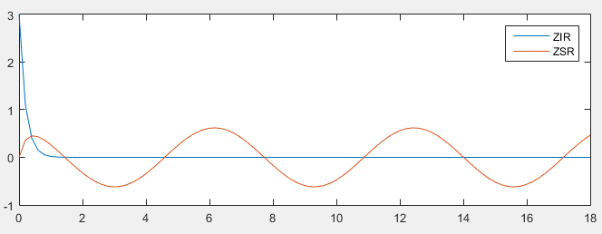  
  
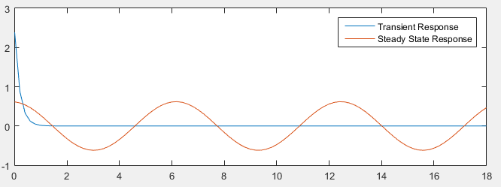  
  
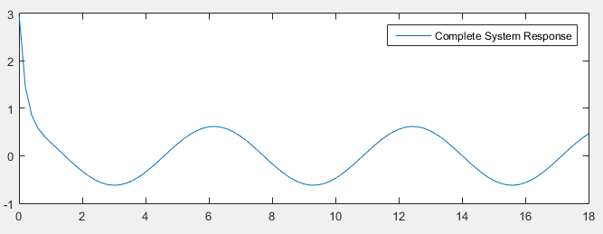  
  
CONCLUSION/DISCUSSION:**From the graphs, it can be inferred that as the time progresses, the transient part becomes zero and the steady state starts to take over.

The Zero Input Response is

$$3 e^{-5t} u(t)$$

The Zero State Response is

$$-\frac{e^{-5t}}{13} (8 u\left(t\right)- e^{5t} \left(8\cos{t}-\sin{t}\right) u\left(t\right))$$

The calculated Transient Response was achieved to be

$$\frac{31}{13} e^{-5t} u(t)$$

The Steady State Response was calculated to be

$$\frac{8}{13} e^{-5t}- \frac{e^{-5t}}{13} (8 u\left(t\right)- e^{5t} (8\cos{t-\sin{t) u(t)}}$$